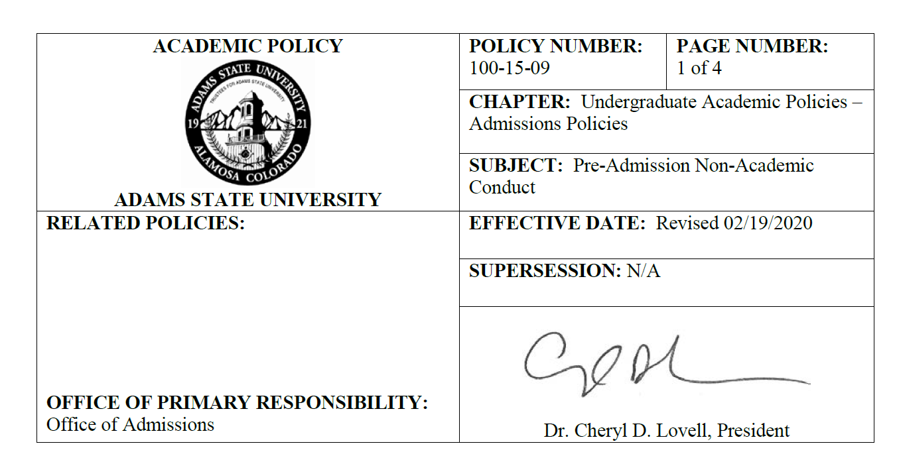
I. POLICY

In compliance with Colorado Senate Bill 19-170 and the Department of Education’s Pell guidance for incarcerated students, the governing board of Adams State University shall not inquire into, or require disclosure of an applicant's criminal history, or disciplinary history at another academic institution, on any form of application, including electronic applications, for admission to the institution. Adams State University may inquire into any of the following in post-admission enrollment pathways at the undergraduate-level to determine which support networks should provide outreach and connection to enrolled students or in pre-admission processes at the graduate-level to determine if applicants can access licensure post-graduation in specific academic programs: (a) an applicant's prior convictions for stalking, sexual assault, and domestic violence; (b) an applicant's prior convictions, within five years before submitting the application, for assault, kidnapping, voluntary manslaughter, or murder; (c) an applicant's prior disciplinary history at another academic institution for stalking, sexual assault, and domestic violence; (d) any criminal charges pending against the applicant; and (e) an applicant's educational records related to academic performance.

. Programs requiring licensure post-graduation may have additional requirements and disclosures. Students with Non-Academic Conduct or Criminal History will receive appropriate and transparent communications throughout the enrollment lifecycle to successfully complete degree plans and academic programs.

Adams State University may inquire into an admitted applicant's criminal history when obtaining information pertaining to participation in campus life or student housing. For such inquiries, Adams State University shall consider the following: (a) if there are pending charges against the student that may inhibit or bar enrollment and class engagement; (b) if the student is on parole or suspension since the Chief of Police at Adams State University will need to receive communication from the Parole Officer, notice of visits, and Parole Officer visitation may occur at times when other students are present ; t; and (c) if the student has restraining orders filed against them by members of the existing campus community as that may impact class and housing placement .

Pursuant to Colorado Senate Bill 19-170, this policy, including the student’s right to appeal procedure, must be filed with the Colorado Commission for Higher Education. Any change to the policy must be filed at least thirty days prior to enactment.

CHAPTER: SUBJECT: POLICY NO.: Page 2 of 4

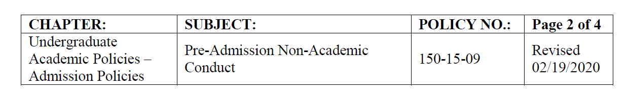

II. PURPOSE

This policy establishes that Adams State University’s (ASU) policy and procedure for addressing nonacademic misconduct of applicants for admission complies with Colorado Senate Bill 19-170 and the Department of Education’s Second-Chance Pell guidance and takes precautions to facilitate a safe and healthy learning environment for the ASU campus and community while providing applicable support networks for System-impacted, formerly-incarcerated, and other at-risk, underserved populations. The implementation of this policy upholds Adams State University’s mission and commitment to fostering a community of Diversity, Equity, and Inclusion justly for all who seek access to higher education.

III. DEFINITIONS

A. Applicant: a person who has submitted an application for admission to Adams State University with the intention of enrolling in courses as an undergraduate or graduate degree-seeking student.

B. Charged: the commencement of prosecution by the filing of an indictment or presentment, the issuing of a warrant, which is binding over the offender, or by the filing of information.

C. Conviction: means a conviction by a jury verdict or by entry of a verdict or acceptance of a guilty plea or a plea of nolo contendere by a court. "Conviction" does not include a plea to a deferred judgment and sentence until the deferred judgment and sentence is revoked.

D. Student: all persons who are enrolled, have confirmed intent to enroll, or are designated as active and able to enroll in courses at ASU, either full-time or part-time, pursuing undergraduate, graduate or professional studies, as well as non-degree students.

IV. PROCEDURES

A. The President, or designee, shall identify a committee (Campus Assessment, Response and Evaluation Team or CARE Team ) with relevant cross-campus representation chaired by the Vice President for Student Affairs, or designee, to review and make decisions regarding enrollment pathways for admitted students who provide affirmative responses to the onboarding form’s non-academic conduct history questionnaire processed through ASU’s Office of Admissions undergraduate programs.

B. For onboarding forms with affirmative responses, admission application processors will forward the questionnaire to the CARE Team for review. To determine if the student’s housing, class placement, or student life activities at the institution need additional non-academic support programs or poses adverse effect on the safety of the campus community, the CARE Team may inquire into the following:(a) if there are pending charges against the student that may inhibit or bar enrollment and class engagement; (b) if the student is on parole or suspension since the Chief of Police at Adams State University will need to receive communication from the Parole Officer, notice of visits, and Parole Officer visitation may occur at times when other students are present; and (c) if the student has restraining orders filed against them by members of the existing campus community as that may impact class and housing placement.

C. Appeal Procedure: An applicant denied housing, class placement, or student life activities based on information provided on the onboarding formthat the institution would otherwise be prohibited from inquiring into pursuant to Colorado Senate Bill 19-170 has the right to appeal that decision through Adams State University’s CARE Team. The applicant may appeal by writing a letter

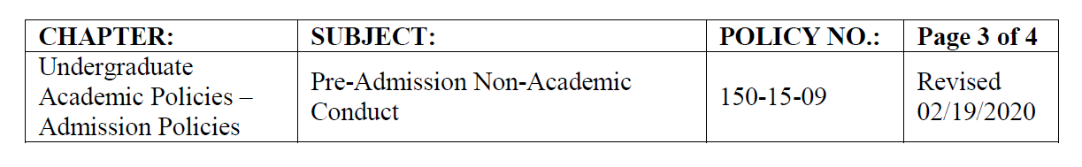
to the CARE Team within 10 days of receipt of denial letter listing any additional relevant information. Appeals must be emailed to studentaffairs@adams.edu or mailed to:
Office of Student Services Affairs
Adams State University
208 Edgemont Blvd. Suite 2080
Alamosa, CO 81101

The CARE Team will review appeals within a reasonable period of time and notify the appellant in writing of the committee’s final decision.

D. For students who are admitted to the institution, the enrollment pathways onboarding form, housing applications, and requests for participation in campus life activities shall ask applicants to answer a criminal history question. Students who answer “YES” are required to supplement the application with criminal history information. This additional information will be submitted to the CARE Team for approval to live in campus housing (or participate in campus life activities).

E. Students who, after admission but prior to matriculation, are convicted for stalking, sexual assault, domestic violence, assault, kidnapping, voluntary manslaughter, or murder; or who become charged with any pending criminal charges must notify the Office of Student Affairsimmediately. This information will be added to the student’s file and forwarded to the CARE Team for review. To determine if the student’s successful enrollment and/or completion at the institution is in jeopardy or adversely effects the safety of the campus community, the CARE Teammay inquire into the following: (a)if there are pending charges against the student that may inhibit or bar enrollment and class engagement; (b) if the student is on parole or suspension since the Chief of Police at Adams State University will need to receive communication from the Parole Officer, notice of visits, and Parole Officer visitation may occur at times when other students are present; and (c) if the student has restraining orders filed against them by members of the existing campus community as that may impact class and housing placement..

F. Students who, after matriculation, are convicted for stalking, sexual assault, domestic violence, assault, kidnapping, voluntary manslaughter, or murder; or who become charged with any pending criminal charges affecting Housing, Class Placement, or Campus Life Activities must notify the Office of Student Affairs immediately.

1. The Vice President of Student Affairs sends written notice to the student and notifies them that ASU has become aware of the charge or criminal history, addresses any other information known to the University about the matter, and the applicable consequences (e.g.,student is temporarily suspended effective immediately). When applicable, the Vice President for Student Affairs’ notice may also include a Prohibition Order. If such an order is included, it is the responsibility of the student to not have contact with the individual(s) named, directly, or through third parties, as specified in the notice. Failure to comply with the order may result in additional disciplinary action through the Student Code of Conduct procedures.

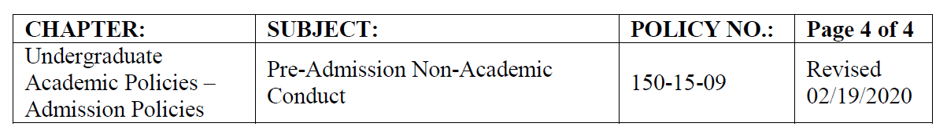
2. A conference between the student and the Vice President for Student Affairs or his or her designee, shall be scheduled as soon as possible (usually within 10 calendar days of the notice) for the limited purpose of the student and the Vice President for Student Affairs exchanging information regarding the charge and to allow the student to present any mitigating information regarding whether the temporary suspension should continue. This conference is not for the purposes of investigating the charge.

3. The Vice President for Student Affairs, or designee, shall refer the matter to the CARE Team for evaluation. The CARE Team shall be authorized to review and make a decision regarding the charges, including, but not limited to whether the student is eligible to continue to enroll, whether the student’s prior admission shall be revoked, or whether the student will be suspended in abeyance. A temporary suspension may continue to be in effect until the committee has made such a determination.

V. RESPONSIBILITY

A. Office of Student Affairs – Vice President for Student Affairs
B. Campus Assessment, Response and Evaluation Team (CARE Team)

VI. AUTHORITY

C.R.S. 23-5-106.5
Colorado SB 19-170
C.F.R. 34-B-VI

VII. HISTORY

Policy 100-15-09 “Applicant Criminal History and Pre-Admission Crimes” approved July 2013.

VIII. ATTACHMENTS

None

