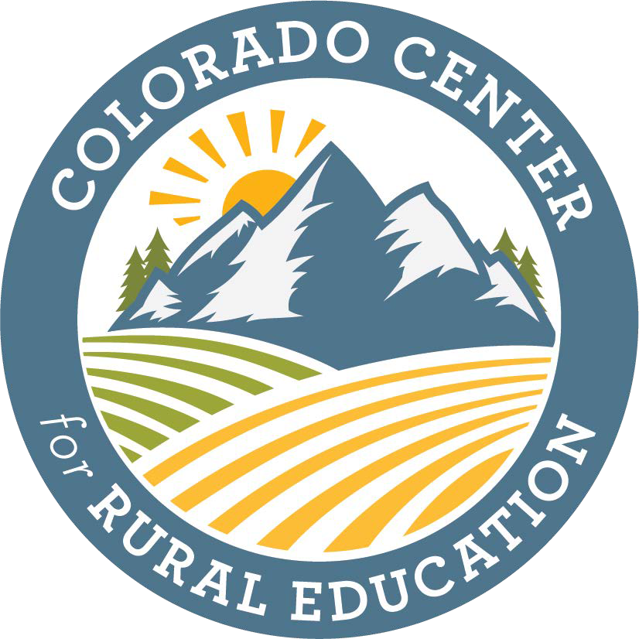

***Concurrent Enrollment Educator Qualification Stipend***

The Colorado Center for Rural Education and the Colorado Department of Higher Education seek to encourage talented K-12 educators in rural Colorado school districts to pursue qualification to be eligible to teach concurrent enrollment courses. The value of the stipend is up to $6,000 for completion of an approved program offered by one of Colorado’s institutions of higher education. If selected as a Concurrent Enrollment Educator Qualification Scholar, the recipient will receive half the stipend amount at the start of the program (first $3,000) and the remaining half (second $3,000) when he/she successfully completes the program and is fully qualified to teach concurrent enrollment courses.

# Eligible Applicants Must Meet the Following Criteria:

1. Evidence of full admission to a program at one of Colorado’s institutions of higher education to take the necessary coursework to fulfill the [qualifications of college faculty](https://www.hlcommission.org/Publications/determining-qualified-faculty.html) (e.g., copy of official admission letter from the Graduate School).
2. Provide a written timeline for program completion. Normally this is within three years of starting the program.
3. Prepare a written statement summarizing the applicant’s commitment to quality rural education and the expected value to be added to the applicant’s school district upon completion of the program.
4. Provide letters of recommendation and endorsement from the applicant’s school principal and district superintendent delineating how this qualification will benefit the school/district.
5. Commitment to complete a Master’s degree, if the applicant does not already hold this degree, which is required to teach concurrent enrollment classes.
6. Commitment to teach concurrent enrollment classes in a Colorado rural school district for a minimum of three years. Applicants awarded the Concurrent Enrollment Educator Qualification Stipend will be required to sign a promissory note.

**Definition of Colorado Rural School District:** A Colorado school district is determined to be rural giving consideration to the size of the district, the distance from the nearest large urban/urbanized area, and having a student enrollment of 6,500 students or less. Small rural districts are those districts meeting these same criteria and having a student population of less than 1,000 students.

**Phone** 970-351-4954 • **Office** McKee Hall 282A • **Email** [Diana.Podein@unco.edu](mailto:Diana.Podein@unco.edu) [www.unco.edu/colorado-center-for-rural-education](http://www.unco.edu/colorado-center-for-rural-education)

**Mail** UNC Colorado Center for Rural Education, 501 20TH Street, Campus Box 106, Greeley, CO 80639-0028